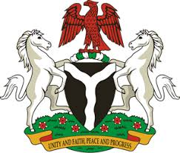
Please check against delivery
HUMAN RIGHTS COUNCIL
33RD SESSION OF THE WORKING GROUP OF THE UPR
REVIEW OF THE FEDERAL DEMOCRATIC REPUBLIC OF ETHIOPIA
14TH MAY, 2019
STATEMENT BY NIGERIA
Madam Vice President,
Nigeria warmly welcomes the delegation of the Federal Democratic Republic of Ethiopia to the presentation of its National Report for the Third Cycle UPR. We commend the Government of Ethiopia for its continued cooperation with human rights mechanisms and its efforts in implementing the previous recommendations.
2. We applaud the Government of Ethiopia for the implementation of its second Growth and Transformation Plan, aimed at accelerated and sustainable economic growth, with a view to reducing poverty. The country’s commitment to regional peace and security are worthy of commendation.
3. In the spirit of constructive dialogue, Nigeria recommends the following for the consideration of Ethiopia:
- To continue its efforts in enhancing the socio-economic well-being of its people; and
- To sustain its efforts in combatting terrorism, and promoting peace and security.
4. Finally, we wish Ethiopia a very successful review process.
I thank you Madam Vice President.
******

