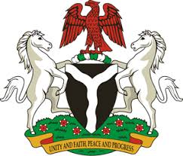
Please check against delivery
HUMAN RIGHTS COUNCIL
33RD SESSION OF THE WORKING GROUP OF THE UPR
REVIEW OF THE REPUBLIC OF EQUATORIAL GUINEA
13TH MAY, 2019
STATEMENT BY NIGERIA
Mr Vice President,
Nigeria warmly welcomes the delegation of the Republic of Equatorial Guinea to the presentation of the country’s Third Cycle UPR National Report, and thanks them for the update provided today. We commend the Government of Equatorial Guinea for its continued cooperation and engagement with the UPR process and other human rights mechanisms, as well as its efforts in implementing the previous recommendations.
2. Nigeria lauds the Government of Equatorial Guinea for its commitment to the promotion and protection of the human rights of its people. The country’s efforts in strengthening its legal and institutional frameworks in the field of human rights are also commendable. We also commend the Government for its efforts and strategies in combatting corruption.
3. While noting the country’s efforts in the field of human rights, Nigeria wishes to make the following recommendations to Equatorial Guinea:
- Not to relent in its efforts at providing quality education and health care services for its people; and
- To continue its fights against poverty and corruption.
4. In conclusion, we wish Equatorial Guinea a very successful review process.
I thank you Mr Vice President.
******

