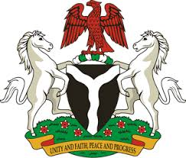
Please check against delivery
HUMAN RIGHTS COUNCIL
33RD SESSION OF THE WORKING GROUP OF THE UPR
REVIEW OF THE KINGDOM OF BHUTAN
8TH MAY, 2019
STATEMENT BY NIGERIA
Mr Vice President,
Nigeria warmly welcomes the delegation of the Kingdom of Bhutan to the presentation of its National Report for the Third Cycle UPR. We commend Bhutan for its commitment to the promotion and protection of human rights, and its continued cooperation with human rights mechanisms, as well as its efforts in implementing the previous recommendations.
2. It is gratifying to note the various measures adopted by the Government of Bhutan in its efforts to combat the scourge of corruption. The country’s strategy and efforts towards poverty alleviation are worthy of commendation. Nigeria also commends Bhutan for its commitment to the promotion and protection of the rights of the vulnerable groups, especially women and children.
3. While acknowledging Bhutan’s efforts in the field of human rights, Nigeria wishes to recommend the following for the consideration of Bhutan:
- Not to relent in its poverty alleviation efforts and the fight against corruption; and
- To keep on mobilising resources and seek necessary international assistance to enhance its capacity to promote and protect human rights.
4. Finally, we wish Bhutan a very successful review process.
I thank you Mr Vice President.
******

