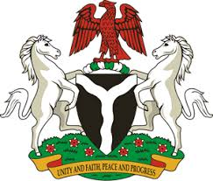
Please check against delivery
HUMAN RIGHTS COUNCIL
33RD SESSION OF THE WORKING GROUP OF THE UPR
REVIEW OF THE DEMOCRATIC REPUBLIC OF THE CONGO
7TH MAY, 2019
STATEMENT BY NIGERIA
Mr President,
Nigeria warmly welcomes the delegation of the Democratic Republic of the Congo to the presentation of its Third Cycle UPR National Report. We commend the Government of DRC for its continued cooperation and engagement with the UPR process and other human rights mechanisms, as well as its efforts in implementing the previous recommendations.
2. Nigeria lauds the Government of DRC for its efforts in strengthening its legal and institutional frameworks in the field of human rights. We also commend the country’s efforts and commitment to promoting national reconciliation and the adoption and implementation of the National Strategic Development Plan to combat poverty.
3. While noting the numerous efforts by the Government of DRC in the field of human rights, Nigeria wishes to offer the following recommendations to the Democratic Republic of the Congo:
- To continue its efforts in the fight against poverty and the promotion of national reconciliation; and
- To keep mobilising resources and seek necessary international support to enhance its capacity to promote and protect human rights.
4. In conclusion, we wish the DRC a very successful review process.
I thank you Mr President.
******

