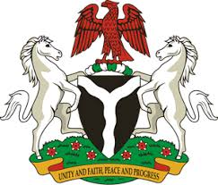
Please check against delivery
HUMAN RIGHTS COUNCIL
33RD SESSION OF THE WORKING GROUP OF THE UPR
REVIEW OF THE DEMOCRATIC PEOPLE’S REPUBLIC OF KOREA
9TH MAY, 2019
STATEMENT BY NIGERIA
Mr President,
Nigeria welcomes the delegation of the Democratic People’s Republic of Korea to the presentation of the country’s National Report for the Third Cycle UPR, and thanks them for the update provided today. We commend the Government of DPRK for its continued cooperation and engagement with human rights mechanisms, and its efforts in implementing the recommendations it accepted during the previous review.
2. We note the commitment of the Government of DPRK to the promotion and protection of human rights, as well as its efforts in strengthening its legal and institutional frameworks in the field of human rights. We also commend the country’s efforts at protecting and empowering women and other vulnerable groups in the society.
3. While acknowledging the country’s efforts in upholding human rights, and in the spirit of constructive dialogue, Nigeria wishes to offer the following recommendations to the Democratic People’s Republic of Korea:
- To sustain its commitment to the promotion and protection of human rights; and
- To scale up its efforts in the promotion and protection of the rights of the vulnerable groups in the society.
4. In conclusion, we wish DPRK every success in its review process.
I thank you Mr President.
******

