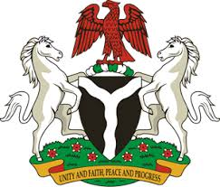
Please check against delivery
HUMAN RIGHTS COUNCIL
33RD SESSION OF THE WORKING GROUP OF THE UPR
REVIEW OF THE REPUBLIC OF COTE D’IVOIRE
7TH MAY, 2019
STATEMENT BY NIGERIA
Mr President,
Nigeria warmly welcomes the delegation of the Republic of Cote d’Ivoire to the presentation of its National Report for the Third Cycle UPR. We commend the Government of Cote d’Ivoire for its commitment to the promotion and protection of human rights, and its continued cooperation with human rights mechanisms, as well as its efforts in implementing the previous recommendations.
2. Nigeria notes with encouragement, Cote d’Ivoire’s ratification of a number of international instruments, and its efforts in further strengthening its legal and institutional frameworks for the promotion and protection of human rights. The country’s strides in poverty alleviation and addressing the plights of the vulnerable groups are also commendable.
3. While acknowledging the successes recorded by Cote d’Ivoire in the field of human rights, Nigeria wishes to recommend the following to Cote d’Ivoire:
- To sustain its efforts in poverty alleviation and addressing the plights of vulnerable groups in the society; and
- To continue to mobilise resources and seek necessary international support for the promotion and protection of human rights.
4. Finally, we wish Cote d’Ivoire a very successful review process.
I thank you Mr President.
******

