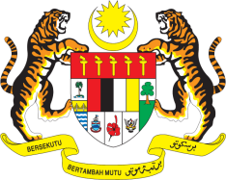

STATEMENT BY MALAYSIA
Review of Portugal
33rd Session of the UPR Working Group
6-17 May 2019

Thank you, Mr. President.

Malaysia welcomes the delegation of Portugal and thanks them for the presentation of their national report.

- We acknowledge Portugal’s progress since its last UPR, especially in the development and implementation of human rights policies, programmes as well as legislations in areas such as public health, employment, trafficking in persons, gender equality and child poverty, among others. We are also pleased to note that Portugal will endeavour to incorporate human rights elements into its 2030 Agenda strategies and policies.

- In the spirit of constructive engagement, Malaysia would like to offer Portugal the following recommendations:

  - First: Strengthen measures to address all forms of discrimination against minorities;
3.2. Second: Ensure inclusive education and accessibility of health-care services and facilities for persons with disabilities;
3.3. Third: Continue efforts in the protection of children including through the finalisation of the National Strategy which is aimed to improve the implementation of the Convention on the Rights of the Child;
3.4. Fourth: To adopt further measures to ensure full enjoyment of rights of women particularly in education and employment sectors; and
3.5. Fifth: Take further steps to ensure gender-based violence cases are reported and perpetrators are prosecuted.

- Malaysia wishes Portugal a successful review.

I thank you, Mr. President.

GENEVA
8 May 2019

