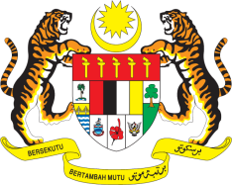

STATEMENT BY MALAYSIA
Review of Albania
33rd Session of the UPR Working Group
6-17 May 2019

Thank you, Mr. President.

Malaysia welcomes the delegation of Albania and thanks them for the detailed national report and update.

- The efforts taken by the Government of Albania in implementing recommendations accepted during Albania’s Second UPR including those made by Malaysia are commendable. We welcome Albania’s commitment to further solidify efforts in the protection and promotion of human rights in the country, among others, by harmonising national regulations with international obligations and improving legal framework particularly in the areas of children, women, persons with disabilities and minorities’ rights.

- In the spirit of constructive engagement, Malaysia would like to submit the following recommendations which we believe would further complement Albania’s efforts in advancing human rights in the country:

3.1. Continue efforts in the promotion and protection of human rights by strengthening national policies and programmes;

3.2. Make improvements in the health sector to address the concern raised by the Committee on the Elimination of Discrimination against Women concerning mother-to-child transmission of HIV; and

3.3. Continue providing adequate resources for prevention and rehabilitation services for victims of domestic violence.

- Malaysia wishes Albania a successful review.

I thank you, Mr. President.

GENEVA
6 May 2019

