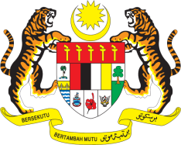

STATEMENT BY MALAYSIA
Review of Norway
33rd Session of the UPR Working Group
6-17 May 2019

Thank you, Mr. President.

Malaysia welcomes the delegation of Norway and thanks them for the presentation of their national report.

- Malaysia commends Norway for numerous significant developments since its second UPR. We wish to recall Malaysia’s recommendations and welcome, in this regard, the establishment of the Norwegian Human Rights Institution. We further welcome Norway’s remarkable achievement in promoting gender equality and look forward for greater gender balance in the education and labour market sectors.

- In the spirit of constructive engagement, Malaysia would like to recommend the following:

3.1. Step up measures to combat racism, racial discrimination and xenophobia especially against minorities;
3.2. Implement robust measures in addressing the concern raised by the Committee on the CRC on the increase of online child sexual abuse and exploitation; and
3.3. Continue taking effective measures to prevent sexual violence against women.

- In concluding, my delegation firmly believes that Norway would continue to exert all efforts to protect and promote the freedom as well as rights of people both at the national and international fora to realize the highest attainment of human rights values. We wish Norway a successful review.

I thank you, Mr. President.

GENEVA
6 May 2019

