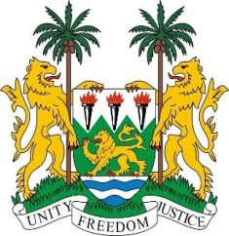

SIERRA LEONE
33rd Session of the UPR

QATAR

15th MAY 2019

Mr Vice President,

Sierra Leone heartily welcomes the distinguished delegation of the State of Qatar and thanks them for their presentation this morning.

My delegation applauds the State of Qatar for acceding to both the ICCPR and the ICESCR a year ago. My delegation notes the series of legislations passed by the State of Qatar aimed at advancing the human rights of expatriate workers.

My delegations further commend the State of Qatar for putting together its second National Development Strategy (2018-2022) which will undoubtedly address some of the SDG`s goals including rights of migrants.

In a constructive spirit we recommend as follows:

- We urge the International community to work with all parties with a view to speedily address the current blockade that has consequently violated particularly the social rights of its people.
- That the national laws be applied and interpreted in conformity with provisions of the Convention on the Elimination of all forms of Discrimination against Women.
- Consider reviewing its existing national security and counter-terrorism laws in conformity with the Convention against Torture and other International Standards.
- Considers to declare inadmissible confessions obtained by means of torture or ill-treatment.

Sierra Leone wishes Qatar every success in completing its third review cycle.

Thank you, Mr Vice President.

