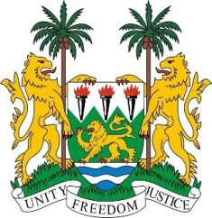

SIERRA LEONE
33rd Session of the UPR

ETHIOPIA

14th MAY 2019

Mr President,

Sierra Leone warmly welcomes the distinguished delegation of Ethiopia and thanks them for their presentation this morning.

My delegation applauds Ethiopia for its far-reaching political reforms since March 2018 with the widening of the political and civic space by way of pardoning convicted prisoners, dropping charges against political figures, activists, journalist and declassifying armed groups designated as terrorist.

My delegation notes Ethiopia`s full commitment and her effective relationship with member states of the African Union and the United Nations towards the implementation of its obligations vis-à-vis international human rights instruments.

My delegation further notes the overarching strides of her government in every fabric of its society including socio-economy and political transformation, building national peace and cohesion.

In a spirit of cordiality recommend the following

- Expedite the process of acceding to both ICPPE and the ICPRMW.
- Mainstream the rights of women with disabilities in law and practice.
- That it considers repealing specific provisions of the Family Code that creates room for discrimination on the basis of disability regarding rights of the family.

Sierra Leone wishes Ethiopia every success in completing its third review cycle.

Thank you, Mr President.

