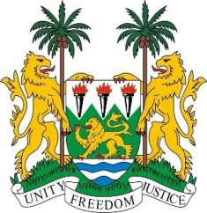
SIERRA LEONE
33rd Session of the UPR

BHUTAN

8th MAY 2019

Mr Vice President,

Sierra Leone welcomes the distinguished delegation of Bhutan and thanks them for their presentation.

My delegation applauds Bhutan`s strides in achieving the SDG goal 4 of quality education to particularly vulnerable and economically disadvantaged students.

My delegation further notes that Bhutan has made significant progress in terms of gender parity in education as well as the launch of a pilot project aimed at addressing gender-based violence against women and children.

In a constructive spirit, my delegation recommends the following

- We urge Bhutan to take the requisite steps to address the existing gaps that affects particularly women`s rights.
- Promulgate desired legislations with a view to addressing the needs of the aged.
- Ratify the Second Optional Protocol to the ICCPR and the ICPPED.
- Expedite the establishment of an organ with its terms of reference to coordinate all activities related to the full implementation of its ratified human rights treaties.

Sierra Leone wishes Bhutan every success in completing its third review cycle.

Thank you, Mr Vice President.

