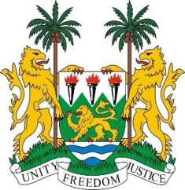

SIERRA LEONE
33rd Session of the UPR

EQUITORIAL GUINEA

13th MAY 2019

Mr President,

Sierra Leone welcomes the distinguished delegation of Equatorial Guinea and thanks them for their presentation.

My delegation commends Equatorial Guinea for taking concrete steps in adopting a national plan titled Horizon 2020 with its agenda aimed at boosting the human capital of the country and to improve the quality of life of its people.

My delegation notes that despite the country`s delay in ratifying the convention on the rights of person with disabilities, it is however taking steps in improving the living conditions of such persons.

My delegation commends Equatorial Guinea for its partnership with the Medical Care Development International in developing the Bioko Island Malaria Control Project which involves the participation of community stakeholders.

In a constructive spirit we recommend the following:

- We call on Equatorial Guinea to effectively address allegations of political persecutions, arbitrary arrest and the overall conditions that undermine the dignity of persons in detention.
- Take measures with a view to effectively apply Act No. 1/2004 on the smuggling of migrants and trafficking in persons.
- Expedite the approval of the Family Code which is aimed at eradicating gender-based disparities and prevention of violence against women.

Sierra Leone wishes Equatorial Guinea every success in completing its third review cycle.

Thank you, Mr President.

