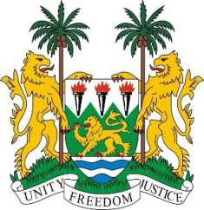
SIERRA LEONE
33rd Session of the UPR

COTE D`IVOIRE

7th MAY 2019

Mr President,

Sierra Leone welcomes the distinguished delegation of Cote d`Ivoire and thanks them for their presentation.

Following the Interactive Dialogue of April 2014, my delegation commends Cote d` Ivoire for developing and adopting a good number of legislations to strengthen its national normative framework.
My delegation further note the country`s effort to reform its judicial and prison system.

Mr. President, my delegation is particularly impressed with Cote D`Ivoire`s governance reform with specific reference to its National Development Plan for the period 2016 – 2020.

Recommendations:

- Expedite the process of accession to the Optional Protocol to the Convention against Torture and other Cruel Degrading Inhuman or Treatment or punishment.
- Accede to the Second Optional Protocol to the ICCPR with a view to abolishing the death penalty.
- Improve on Press Freedom even though the National Assembly in December 2017 adopted a law on the press that in principle prohibit detaining or imprisoning journalist.

Sierra Leone wishes Cote d`Ivoire every success in completing its third review cycle.

Thank you, Mr President.

