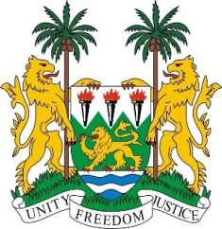
SIERRA LEONE
33rd Session of the UPR

DEMOCRATIC REPUBLIC OF CONGO

7th MAY 2019

Mr President,

Sierra Leone welcomes the distinguished delegation from the Democratic Republic of Congo to this 33rd session and thanks them for their presentation.

My delegation commends the DRC for the series of measures taken in building institutional framework for the protection of human rights particularly the operationalisation in June 2018 of the Court of Cassation and the Council of State.

Sierra Leone notes the DRC`s efforts in implementing well over 190 recommendations following the country`s participation in the 2nd review cycle in April 2014. Sierra Leone applauds the DRC for adopting 4 (four) legislations giving effect to the Rome Statute of the International Criminal Court.

Recommendations:

- Designate or establish an independent national mechanism for the prevention of torture.
- Take steps to promulgate legislations aimed at promoting and protecting all forms of human rights including rights to peaceful demonstration and the rights of indigenous pygmy people.
- We urge the international community to provide the requisite support to put an end to the deadly ebola scourge in the DRC.
- Continue to work with both local and international players in bringing lasting peace to that war-torn country.

In conclusion, Sierra Leone wishes the DRC every success in completing this third review cycle.

Thank you, Mr President.

