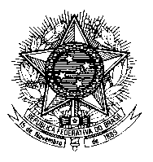

Permanent Mission of Brazil to the United Nations Office
and other International Organizations in Geneva

Human Rights Council

Universal Periodic Review

DPRK

1’20’’ – 206 palavras

Mr. President,

Brazil welcomes the delegation of the Democratic People’s Republic of Korea. We present the following recommendations:

1) To ensure that the government`s policies on access to food and distribution are free from discrimination and political considerations;

2) To adopt concrete measures to address the root causes of infant and child mortality, including social and economic deprivation and inequality, child malnutrition and child labour.

Brazil remains deeply concerned about the persistent reports of grave and systematic violations of human rights, including restrictions on civil and political rights, such as the rights of freedom of opinion and
speech, religion, belief, movement and privacy, as well as systematic abduction and enforced disappearance.

We urge the DPRK to cooperate with the United Nations human rights mechanisms, including by providing all the necessary conditions for visits by special procedures to the country.

We note the ratification of the Optional Protocol on the Sale of Children, Child Prostitution and Child Pornography and the CRPD and encourage the authorities to take further measures to implement them.

Brazil acknowledges the strengthening of cooperation related to the rights to health and education. We recognize the challenges faced to combat poverty and to advance farming methods.

Thank you.

