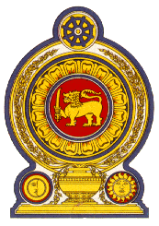

Statement by the Democratic Socialist Republic of Sri Lanka
33rd Session of the Universal Periodic Review

Review of Brunei Darussalam – 10 May 2019

Sri Lanka warmly welcomes the delegation of Brunei Darussalam and appreciates the comprehensive presentation made.

We commend action taken by Brunei to improve the standards of living of its people, through addressing income disparities, ensuring universal access to clean drinking water, and providing free education and affordable social services including quality healthcare.

We take positive note of Brunei’s ratification of the Convention on the Rights of Persons with Disabilities (CRPD) and the decision to withdraw reservations under the Convention on the Rights of the Child (CRC). Progressive legal reforms regarding child labour and the law of evidence are also noted.

We further welcome the increased level of participation of Brunei women in the labour force and the greater space created for women to take up non-traditional employment.

Sri Lanka recommends that Brunei Darussalam:

1. continues efforts towards aligning its national legislation, policies and programmes on women and children with the Convention on the Elimination of All forms of Discrimination Against Women (CEDAW) and the Convention on the Rights of the Child (CRC);

2. incorporates the provisions of the CRPD into its national legal framework and effectively implements the Different Abilities Design Guidelines; and

3. further strengthens human rights education in the country and expands engagement with stakeholders.

We wish Brunei Darussalam success in its UPR engagement.

