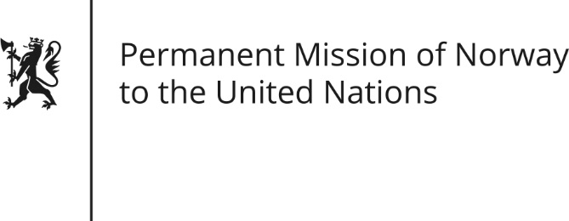

STATEMENT by Minister Counsellor Herborg F. Alvsaaker

33rd Session of the Universal Periodic Review

Brunei Darussalam

10 May 2019

Check against delivery
President,
Norway welcomes Brunei Darussalam’s participation in the UPR-process.
We are concerned about the introduction of certain provisions in the new Sharia laws, which adversely affect the human rights developments in Brunei Darussalam.
Norway recommends Brunei to:
1) Declare and uphold a de facto moratorium on the application of death penalty, as a first step towards its full abolition
2) Ratify the Convention against Torture and Other Cruel, Inhuman or Degrading Treatment or Punishment
3) Ensure equal rights and fair treatment to all, regardless of race, nationality, gender or sexual orientation
4) Amend the Sedition Act to strengthen freedom of expression in line with international human rights obligations

Thank you.

