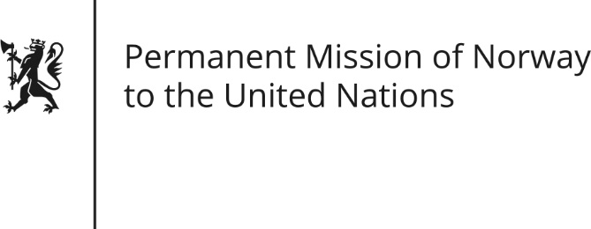

STATEMENT by First Secretary Hanna Olsen Bodsberg

33rd Session of the Universal Periodic Review

08 May 2019

Check against delivery

President,

[Norway welcomes Portugal’s participation in the UPR and notes the positive steps taken since the last review, in particular to tackle violence against women and to promote equality between women and men.]

Norway recommends:

1) Continue efforts to increase transparency in all levels of governance, hereunder ensuring due implementation of laws and regulations on access to information, in order to facilitate democratic participation and control.

2) Strengthen work on anti-corruption, hereunder fully implement the recommendations by GRECO made in the fourth evaluation round.

3) Intensify efforts to combat domestic violence, as well as ensure that victims of domestic violence, hereunder dependents, are provided with adequate support and access to effective justice.

4) Adopt effective measures to prevent the excessive use of force in the justice sector, and ensure that all allegations thereof are investigated in a timely and efficient manner.

Thank you

