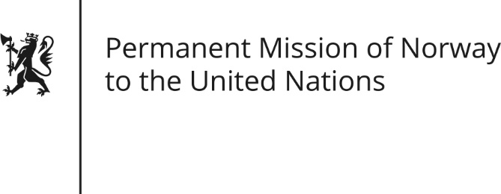

STATEMENT by Deputy Director Per Kristian Roer

33rd Session of the Universal Periodic Review

Nicaragua

15 May 2019

Check against delivery
President,
Norway remains deeply concerned about the human rights situation in Nicaragua and recommends Nicaragua to:
1) Respect the rights to freedom of expression, association and assembly, by ending the repression of people involved in peaceful protests and allowing human rights defenders, civil society organizations and media to carry out their work
2) Release all those arbitrarily or illegally detained; guarantee due process; and assure that the conditions of detention are compliant with international human rights obligations.
3) Guarantee a thorough and transparent accountability process by ensuring access to justice and reparation for the victims of human rights violations.
4) [Resume its cooperation with the OHCHR, the mechanisms of the Human Rights Council, as well as the OAS and the Inter-American Commission on Human Rights.]
5) [Survey the extent of unsafe illegal abortions and introduce measures to safeguard women's universal right to life and health]
Thank you.

