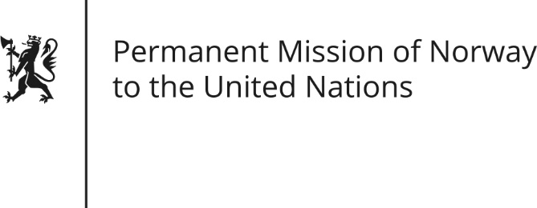

STATEMENT by Minister Counsellor Herborg F. Alvsaaker

33rd Session of the Universal Periodic Review

Qatar

15 May 2019

Check against delivery
President,
Norway welcomes Qatar’s participation in the UPR and notes the positive steps taken since its last review, including important legal reforms concerning the protection of guest workers.
Norway remains concerned about women’s rights and the protection of workers employed in private households. [The UN Convention on Elimination of all Forms of Discrimination against Women (CEDAW), to which Qatar is a State Party, clearly sets out the need to grant equal rights to all women and men.]
Norway recommends:
1) Adopt and implement measures and legal protection to improve conditions for domestic workers, including mechanisms for complaints and sanctions for violations.
2) Ensure the legal rights and protection of women by withdrawing its reservation and aligning its national laws to the Convention on the Elimination of All Forms of Discrimination Against Women.
3) Take measures to remove existing restrictions on the free exercise of freedom of religion and belief of its citizens
4) To undertake an inclusive process with a wide range of civil society representatives when implementing the UPR recommendations.
Thank you.

