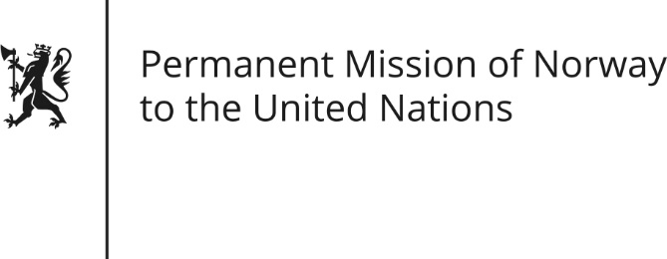

STATEMENT by First Secretary Anne Karine Jahren

33rd Session of the Universal Periodic Review

Ethiopia

14 May 2019

Check against delivery
President,
Norway notes the many positive steps taken in Ethiopia, including the strengthening of freedom of expression and the revision of the Charities and Societies Proclamation. The growing number of internally displaced persons during the past year is concerning.
Norway recommends Ethiopia to:
1) Ratify the Kampala Convention and create a policy framework for all internally displaced persons.
2) Re-examine the penalty framework for perpetrators of sexual violence, and increase the resources dedicated to combating sexual and gender-based violence.
3) Expedite the process of reconciliation through the National Reconciliation Commission, while fully engaging with all stakeholders.
4) Develop a national action plan for the implementation of the United Nations Guiding Principles on Business and Human Rights.
Thank you.

