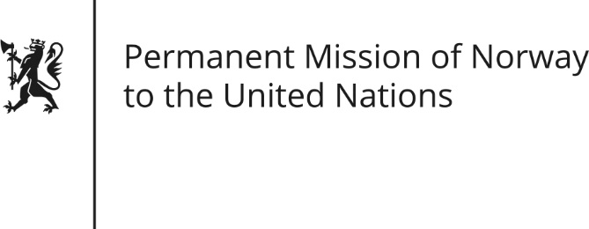

STATEMENT by Minister Counsellor Herborg F. Alvsaaker

33rd Session of the Universal Periodic Review

the Democratic People`s Republic of Korea

09 May 2019

Check against delivery
President,
Norway thanks the DPRK delegation for presenting its national report, and for its participation in international dialogue, including the UPR-process.
We remain deeply concerned about grave human rights violations in the DPRK.
The situation for vulnerable groups, in particular children, remains of special concern.
We recommend to establish a system to prevent sexual violence against women in detention.
We further recommend that the DPRK continues its efforts to provide persons with disabilities equal access and rights to health care and education.
[Norway has continuously provided humanitarian assistance to the people of DPRK.] We underline the importance of granting humanitarian access. We recommend that unlimited humanitarian access to all provinces of the country is secured.
Finally, we recommend that access also be given to the UN Special Rapporteur on the situation of Human Rights in the DPRK.

Thank you.

