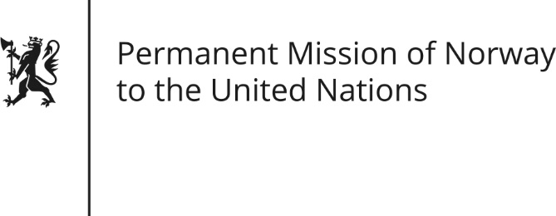

STATEMENT by First Secretary Sean Lobo

Democratic Republic of the Congo

33rd Session of the Universal Periodic Review

07 May 2019

Check against delivery
President,
Norway welcomes the Democratic Republic of Congo’s participation in the UPR.
Norway has taken good note of the important upcoming local elections, and encourage that they be held in a transparent, inclusive and peaceful manner.
We have also taken note of efforts to protect human rights defenders, but remain concerned about their situation, including those working on environmental issues.
Norway recommends that the DRC:

1) Pass the proposed law from 2014 on the fundamental principles for promoting and protecting the rights of the DRC’s indigenous peoples.

2) Adopt effective measures to combat sexual and gender-based violence in order to reduce impunity.
3) Implement the new national action plan on women, peace and security [for the years 2018 to 2022].

4) Take concrete steps to create and maintain a safe and enabling environment for all human rights defenders
5) Take measures to eliminate discriminatory practices against women, including ensuring the respect of women’s land inheritance.
Thank you.

