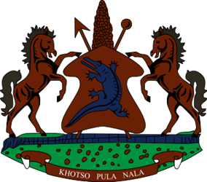
STATEMENT BY LESOTHO DELEGATION DURING THE THIRTY-THIRD SESSION OF THE UNIVERSAL PERIODIC REVIEW WORKING GROUP ON COTE D’ IVOIRE,
07 MAY 2019
Thank you Mr. President
Lesotho welcomes the delegation of Cote d’Ivoire to the working Group and thank them for the presentation of their Report in view of the 3rd UPR cycle. We wish to applaud Cote d’Ivoire for progress made in terms of building the democratic space, strengthening the rule of law, human rights and fundamental freedoms of its people.
In this regard, Lesotho would like to present the two following recommendations to the delegation of Cote d’Ivoire. Firstly, Lesotho encourages Cote d’Ivoire to broaden the mandate of the National Human Rights Commission to address cases of human rights violations, guarantee its independence and bestow it with sufficient resources and financial autonomy so that it may fulfil its mandate effectively in accordance with the Paris Principles. Secondly, we recommend Cote d’Ivoire to increase measures to eradicate female genital mutilation (FGM) especially in the northern and western parts of the country
Finally, Lesotho wishes the delegation of Cote d’Ivoire a successful UPR review.
I thank you Mr. President.

