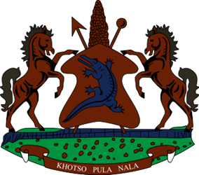
STATEMENT BY LESOTHO DELEGATION DURING THE THIRTY-THIRD SESSION OF THE UNIVERSAL PERIODIC REVIEW WORKING GROUP ON ETHIOPIA, 14 MAY 2019
Thank you Mr. President
Lesotho welcomes the distinguished delegation of Ethiopia to the 33rd Session of the Working Group. We thank them for their comprehensive National Report and the oral update. We also comment the strides Ethiopia has undertaken to safeguard sexual and reproductive rights of women and girls, through the development of the National Reproductive Health Strategy, among others
We further comment Ethiopia for taking steps to alleviate the societal attitudes and stereotypes directed to persons with disabilities. This is evidenced by the ratification of CRPD and its translation into five local languages, as well as trainings and awareness raising campaigns to popularise and implement the Convention.
At this point, Lesotho would like to recommend Ethiopia to some review provisions of the Charities and Societies Proclamation which may seem to be infringing on the human rights of civil society organisation. Secondly, we recommend Ethiopia to adopt a comprehensive and inclusive law on gender-based violence, addressing all forms of violence against women.
Finally, Lesotho wishes Ethiopia every success in implementing the recommendations made.
I thank you Mr. President.

