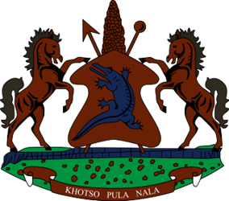
STATEMENT BY LESOTHO DELEGATION DURING THE THIRTY-THIRD SESSION OF THE UNIVERSAL PERIODIC REVIEW WORKING GROUPON DRC, 7 MAY 2019
Thank you Mr. President
Lesotho welcomes the delegation of DRC to the working Group and thank them for the presentation of their Report. We comment them for the progress made since their last review, especially in the protection and promotion of children’s rights to health and education. We take note of the training and popularisation of the Convention of the Rights of the Child and the Child Protection Act as well as measures to increase immunisations rates of children through Expanded Programme on Immunization.
Mr. President,
We comment DRC for undertaking measures to address human rights challenges that the country has grappled with from time immemorial. We note with appreciation a series of dialogues held from 2015 to 2017. Notwithstanding the progress made, Lesotho would like to make the following recommendations for consideration by the delegation of DRC. Firstly, to embark on every measure possible to find a lasting solution to humanitarian and human rights challenges that continue to beset the country.
Secondly, we recommend that DRC ratify the two major outstanding human rights treaties which they are not yet party to.
Finally, Lesotho wishes DRC every success with this UPR cycle.

