Permanent Mission of Rwanda
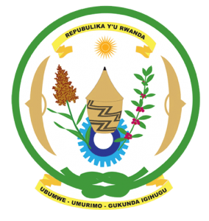
33rd Session of the Universal Periodic Review Working Group

Review of Costa Rica

13th May 2019

Statement delivered by Mr. Moses Rugema

Thank you, Madame Vice President,
Rwanda warmly welcomes the delegation of Costa Rica and thanks them for the presentation of their national report and the updates just provided.
Rwanda welcomes the positive steps taken by Costa Rica to implement the recommendations of its last UPR including through the adoption of legislation and implementation of policies aimed at the promotion and protection of human rights. We particularly welcome steps to promote gender equality and social cohesion.

Rwanda recommends that Costa Rica:
- Strengthen measures to prevent, investigate, prosecute and punish cases of violence against women and domestic violence.
- Strengthen implementation of measures to address marginalisation and discrimination against persons of African descent, including through enhancing institutional capacity to systematically document, investigate and prosecute acts of discrimination.

Rwanda wishes Costa Rica a successful review.
Thank you

