Permanent Mission of Rwanda
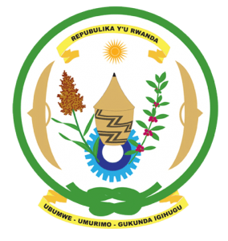
33rd Session of the Universal Periodic Review Working Group

Review of the State Qatar

15th May 2019

Statement delivered by Mr. Moses Rugema

Thank you, Mr. Vice President,
Rwanda warmly welcomes the delegation of the State of Qatar and thanks them for the presentation of their national report and the updates just provided.
Rwanda welcomes the positive steps taken by Qatar to implement the recommendations of its last UPR including through the adoption of legislation and implementation of policies aimed at the promotion and protection of human rights.
We particularly welcome Qatar’s accession to the International Covenant on Civil and Political Rights and the International Covenant on Economic, Social and Cultural Rights and looks forward to their domestication into national legislation without reservations.

Rwanda recommends that the State of Qatar:
- Strengthen measures to further address discrimination against women in law and in practice including through reviewing laws, customs and practices that may constitute discrimination against women and girls.
- Consider the introduction of a de jure moratorium on the use of the death penalty with a view towards its total abolition.
Rwanda wishes Qatar a successful review.
Thank you Mr. Vice President.

