Permanent Mission of Rwanda
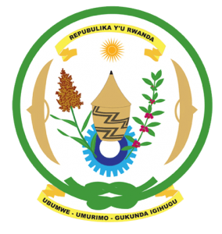
33rd Session of the Universal Periodic Review Working Group
Review of Ethiopia
13th May 2019
Statement delivered by H.E. Dr. Francois X. Ngarambe
Ambassador and Permanent Representative

Thank you, Madame Vice-President,
Rwanda warmly welcomes the delegation of Ethiopia and thanks them for the presentation of their national report and the updates just provided.

Rwanda commends Ethiopia for its continued efforts to promote and protect human rights and to improve the social and economic status of its citizens. We particularly commend Ethiopia for the significant reforms it has undertaken, including in regard to the promotion of gender equality and the empowerment of women and positive steps to foster regional peace and security.

Rwanda recommends that Ethiopia:
- Strengthen implementation of legislation and policies aimed at ending harmful traditional practices in particular child, early and forced marriages and female genital mutilation and eliminate any loopholes that might undermine the protection of women’s rights.
- Consider imposing a de facto moratorium on the use of the death penalty with a view towards its total abolition.
We wish Ethiopia a successful review.
Thank you, Madame Vice President

