Permanent Mission of Rwanda
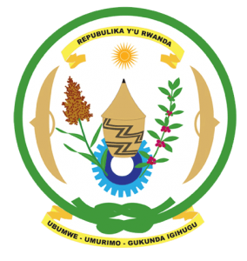
33rd Session of the Universal Periodic Review Working Group
Review of Equatorial Guinea
13th May 2019
Statement delivered by Mr. Moses Rugema

Thank you, Mr. President,
Rwanda warmly welcomes the delegation of Equatorial Guinea and thanks them for the presentation of their national report and the update just provided.

Rwanda commends Equatorial Guinea for its engagement in the UPR process and welcomes the positive steps been taken to implement the recommendations of its last UPR. We welcome Equatorial Guinea’s efforts to improve the social-economic status of its citizens and to address inequality.

Rwanda recommends that Equatorial Guinea:
- Ratify the Convention on the Prevention and Punishment of the Crime of Genocide
- Formally abolish the death penalty and ratify the Second Optional Protocol of the International Covenant on Civil and Political Rights.
- Strengthen measures to eliminate discrimination and violence against women including through the adoption of legislation on gender equality that clearly prohibits discrimination against women

Rwanda wishes Equatorial Guinea a successful review.

Thank you

