Permanent Mission of Rwanda
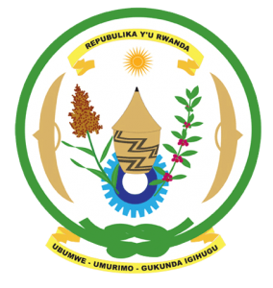
33rd Session of the Universal Periodic Review Working Group
Review of the Democratic Republic of Congo
7th May 2019
Statement delivered by Mr. Moses Rugema
Thank you, Mr. President,
- Rwanda warmly welcomes the delegation of the Democratic Republic of Congo and thanks them for the presentation of their national report and the update just provided.
- Rwanda commends the DRC for the positive steps that have been taken to implement the recommendations of its last UPR including through the adoption of important legislation to address amongst other challenges sexual and gender-based violence.
- We further welcome the recent political developments that will positively contribute to the promotion and protection of human rights in the DRC.

Rwanda recommends that the Democratic Republic of Congo:
- Enhance its efforts to eliminate all negative forces on their territory and where relevant repatriate them to their countries of origin.
- Strengthen measures to combat sexual and gender-based violence including through the implementation of the action plan of the security services to combat sexual violence.
- Abolish the death penalty and ratify the Second Optional Protocol of the International Covenant on Civil and Political Rights.
We wish the DRC a successful review outcome.

