Permanent Mission of Rwanda
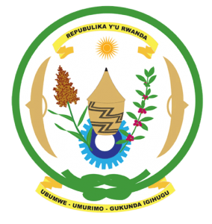
33rd Session of the Universal Periodic Review Working Group
Review of Cote d’Ivoire
7th May 2019
Statement delivered by Mr. Moses Rugema
Thank you, Mr. President,
- Rwanda warmly welcomes the delegation of Cote d’Ivoire and thanks them for the presentation of their national report and the update just provided.
- Rwanda commends Cote d’Ivoire for its continued efforts to promote and protect the human rights of its people and to consolidate the democratic process and foster national reconciliation.
- We particularly commend Cote d’Ivoire for the notable progress it has registered in improving the social and economic status of its citizens and in reforming the judicial sector and improving access to justice.

Rwanda recommends that Cote d’Ivoire:
- Strengthen measures to combat discrimination and violence against women including through the implementation of relevant laws, eliminating any loopholes in national legislation that might undermine the protection of women’s rights and addressing discriminatory stereotypes that affect women.
- Ratify the International Convention on the Protection of the Rights of All Migrant Workers and Members of Their Families.

Thank you

