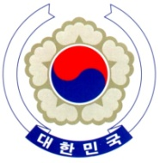

PERMANENT MISSION OF THE REPUBLIC OF KOREA
GENEVA

The 33rd Session of the UPR Working Group <As delivered >
Review of Qatar
Geneva, 15 May 2019

Statement of the Republic of Korea

Thank you, Mr. President.

The Republic of Korea warmly welcomes the delegation of Qatar.

We appreciate that Qatar has strived to promote gender equality, including through the increased participation of women in high-ranking government positions. We also commend the reforms of the Kafala system and the amendments to the Labour Code, as part of Qatar’s institutional efforts to create a safer and fairer environment for migrant workers.

With these achievements in mind, we would like to recommend the following:

- Make further efforts to improve the rights of migrant workers, in particular, by ensuring the effective implementation of relevant laws and policies in accordance with international standards.
- Strengthen its efforts to enhance women’s participation in society, including by conducting awareness raising campaigns for the participation of women and girls with disabilities.

We wish Qatar a successful review.

Thank you, Mr. President. /END/

