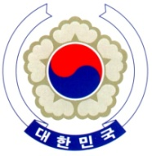

PERMANENT MISSION OF THE REPUBLIC OF KOREA
GENEVA

The 33rd Session of the UPR Working Group <As delivered>
Review of Portugal
Geneva, 8 May 2019

Statement of the Republic of Korea

Thank you, Madam Vice President.

The Republic of Korea welcomes the delegation of Portugal to its third cycle of the UPR.

Our delegation appreciates Portugal’s continued efforts to combat racism and discrimination and to promote the integration of marginalized groups. We also commend the development of national human rights indicators, in particular, on the right to education and the combating of violence against women. We believe increased monitoring and reporting efforts based on these indicators will contribute to the effective implementation of the relevant legal and policy framework.

While wishing Portugal a successful review, we would like to present the following recommendations:

- Strengthen its efforts, in particular within the Action Plan, to prevent and combat domestic violence against women, and ensure that the victims have effective access to protection and the perpetrators are brought to justice.
- Take further steps to protect the basic rights of inmates and improve conditions in detention facilities.

I thank you, Madam Vice President. /END/

