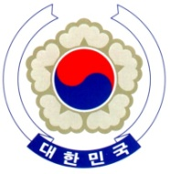

PERMANENT MISSION OF THE REPUBLIC OF KOREA
GENEVA

Universal Periodic Review (3rd Cycle) – Ethiopia <Check against delivery>
Geneva, 14 May 2019

Statement of the Republic of Korea

Thank you, Madame Vice-President,

The Republic of Korea warmly welcomes the delegation of Ethiopia.

My delegation acknowledges Ethiopia’s ongoing political reforms aimed at enhancing the protection of human rights and widening the democratic space. In particular, we commend its recent revision of Charities and Societies Proclamation as part of these reforms.

Bearing this progress in mind, my delegation would like to present the following recommendations to Ethiopia.

- Continue its reform measures to widen the civic space and protect the right to freedom of expression, in particular through the revision of the Anti-terrorism Proclamation and the Media Proclamation;
- Make further efforts to address protection and humanitarian needs of IDPs in the country and to take effective measures to prevent internal displacement caused by internal conflict and natural disasters.

We wish Ethiopia a successful review.

I thank you. /END/

