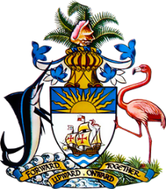

Statement by Ms. Sasha Dixon, Second Secretary
Permanent Mission of The Bahamas to the United Nations Office and Other International Organizations in Geneva
at the 33rd Session of the Universal Periodic Review Working Group
Presentation of National Report by the Government of Nicaragua
15 May, 2019

Thank you Madame Vice President.
The Bahamas extends a warm welcome to the delegation of Nicaragua and we congratulate the country for its demonstrated commitment to this UPR process.
We commend Nicaragua’s implementation of a National Human Development Programme 2018 – 2021 and strategic objectives in sustaining economic growth.
The Bahamas, as a Small Island Developing State, recognizes the challenges faced by Nicaragua with regards to climate change and we commend Nicaragua for representing the developing nations as co-chair of the Green Climate Fund in 2018.
We note the public demonstration that took place mid-April, 2018, and the response of Nicaragua by accepting the invitation for the Inter American Commission on Human Rights to visit the country in May, 2018, and also consenting to creating an International Interdisciplinary Group of Independent Experts.
We further note that Nicaragua asked two key human rights institutions set up by the Inter-American Commission for Human Rights and established in full cooperation with the Government of Nicaragua to leave the country in December, 2018.
The Bahamas therefore recommends that Nicaragua give consideration to allow independent Human Rights bodies’ access to the country as previously extended by the government of Nicaragua
We also recommend that Nicaragua continue its focus on the implementation of the Education Plan for 2017–2021, on promoting initiatives without discrimination at all levels and establish the appropriate curriculum for the promotion of equal access to education for all.
I thank you.

