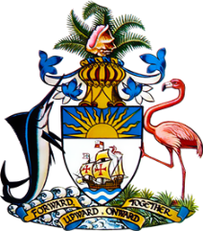

Statement by Ms. Sasha Dixon, Second Secretary
Permanent Mission of The Bahamas to the United Nations Office and Other International Organizations in Geneva
at the 33rd Session of the Universal Periodic Review Working Group
Presentation of National Report by the Government of Portugal
8 May, 2019

Thank you [Mr./Madame] [Vice] President.
The Bahamas extends a warm welcome to the delegation of Portugal.
Portugal is to be commended for the strides it has made in the promotion and protection of human rights in a wide range of areas. Particularly striking are Portugal’s efforts in the area of social inclusion and integration for persons in vulnerable situations such as migrants, minorities, older persons and persons with disabilities. A wide range of policy and programmatic initiatives, which are time-bound and measurable, provide a strong framework for human rights protection efforts at the national level.
We also congratulate Portugal on its leadership in promoting the establishment of National Mechanisms for Implementation, Reporting and Follow-up (NMIRFs) through the Group of Friends here in Geneva.
With a view to encouraging further progress, The Bahamas respectfully recommends that Portugal:
- identify root causes and takes concrete steps to reduce the rates of high early school dropout rates among Roma children;
- increase the effectiveness and accessibility of domestic remedies to respond to complaints of racial discrimination and take measures to address the backlog of pending discrimination complaints;
- strengthen efforts to eliminate discrimination in access to housing and ensure the right to adequate housing for Roma and people of African descent living in substandard conditions.
I thank you.

