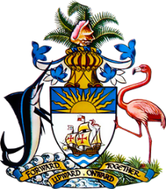

Statement by Ms. Sasha Dixon, Second Secretary
Permanent Mission of The Bahamas to the United Nations Office and Other International Organizations in Geneva
at the 33rd Session of the Universal Periodic Review Working Group
Presentation of National Report by the Government of Norway
6 May, 2019

Thank you Mr. President.
The Bahamas extends a warm welcome to the delegation of Norway.
We congratulate Norway for ongoing efforts in the field of human rights and acknowledge the following noteworthy achievements by the country: the maintenance of an “A” status National Human Rights Institution; the development of a National Strategic Plan for 2020-2030 to improve coordination and integration of efforts to promote the rights of persons with disabilities; ongoing work to craft a new action plan against racism and discrimination; the conduct of training and awareness raising to ensure immigration checks are not conducted in a discriminatory manner and the suite of measures taken and envisaged to combat domestic and sexual violence. The incorporation of climate change and environment considerations into risk assessment for development programmes is also most commendable.
With a view to encouraging further progress, The Bahamas respectfully recommends that Norway:
- ensures equal access to education for all, including upper secondary education, without discrimination on any grounds;
- includes “race” as a prohibited ground of discrimination in the Equality and Anti-Discrimination Act of 2017;
- considers the establishment of a National Mechanism for Implementation, Reporting and Follow-up on human rights recommendations and commitments.
I thank you.

