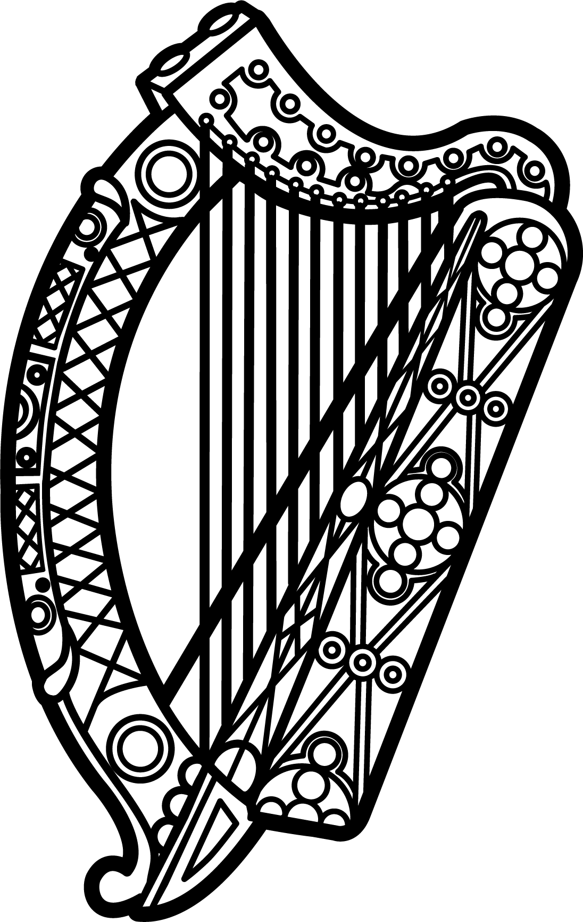

Statement of Ireland
33rd session of the UPR Working Group

Review of Portugal

8 May 2019

Thank you, Mr (Vice) President.

Ireland warmly welcomes the delegation of Portugal and thanks them for their presentation.

Ireland commends Portugal’s efforts to advance human rights domestically and welcomes the progress made since the last UPR cycle, including the adoption of several comprehensive policy instruments such as the National Strategy for Equality and Non-Discrimination.

We also welcome Portugal’s commitment to mainstreaming human rights throughout its national administration and to strengthening dialogue with civil society through the framework of the Portuguese National Human Rights Committee.

Ireland makes the following recommendations to the Portuguese authorities:

- Continue supporting the Ombudsman with the human, financial and material resources necessary to discharge its mandate in full compliance with the Paris Principles.

- Ensure the effective implementation of all relevant legal and policy frameworks intended to combat and prevent domestic violence against women and children, paying particular attention to obstacles that may prevent victims from accessing justice.

We wish Portugal every success with this UPR cycle.

Thank you.

