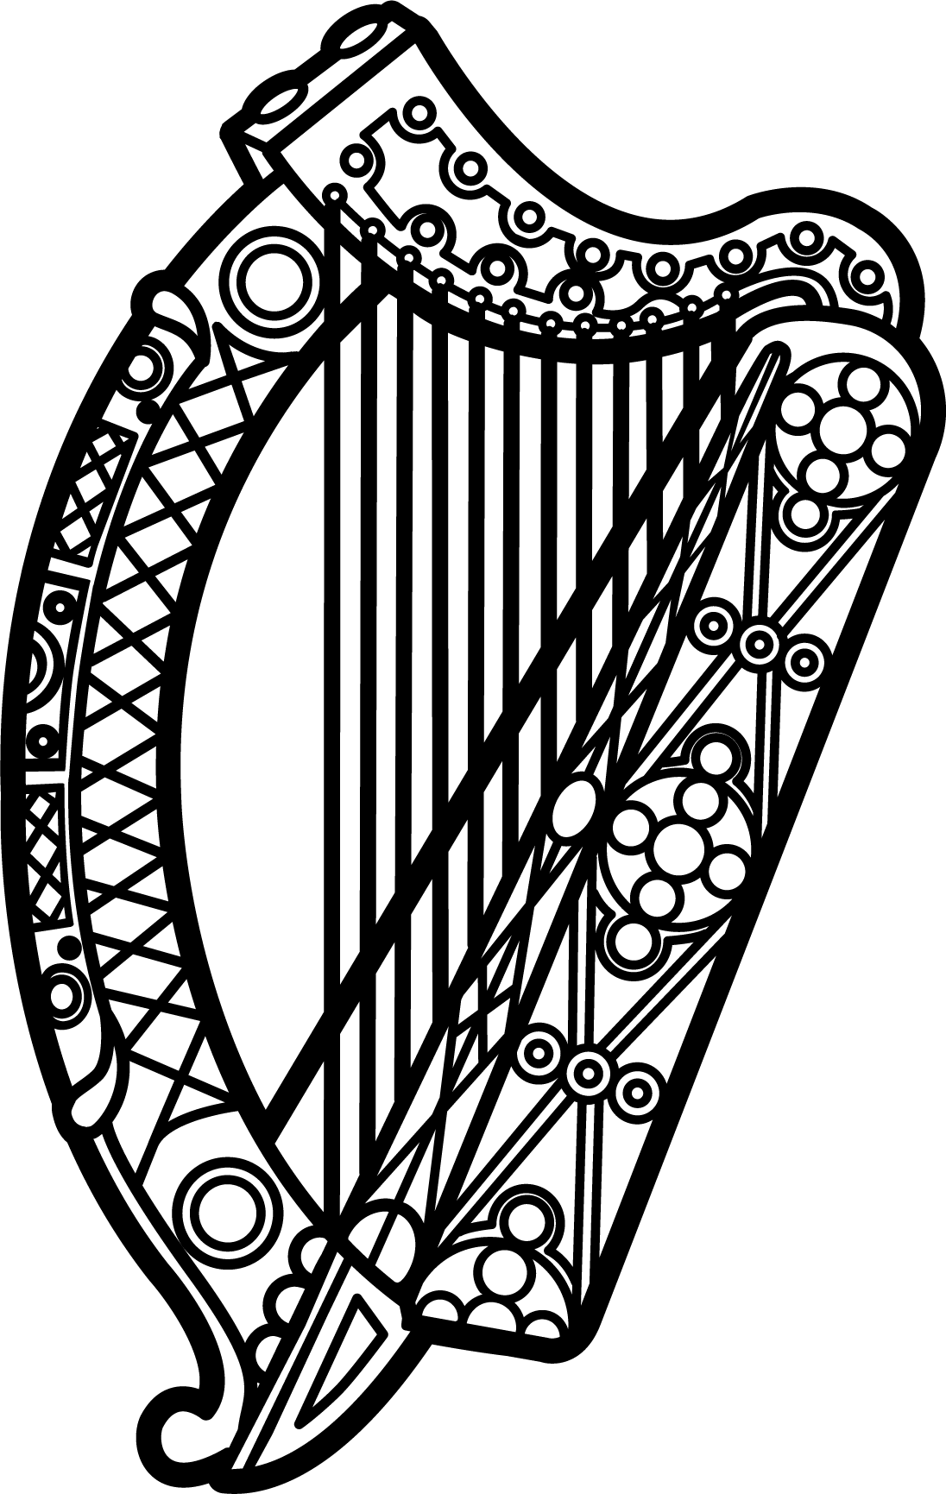

**Statement of Ireland**

**33rd session of the UPR Working Group**

Review of Norway

**6 May 2019**

Thank you, Mr (Vice) President.

Ireland warmly welcomes the delegation of Norway and thanks them for their presentation.

Ireland welcomes Norway’s commitment to protect and promote human rights domestically and commends progress made since the last UPR cycle.

We welcome the addition of a new human rights chapter to the Norwegian Constitution, and further commend Norway on the establishment of a national human rights institution in full compliance with the Paris Principles, as recommended by Ireland during the last UPR cycle.

Ireland makes the following recommendations to the Norwegian authorities:

1. Continue supporting the national human rights institution with the human, financial and material resources necessary to discharge its mandate.
2. Adopt a legal definition of rape in the Penal Code that places the lack of freely given consent at its centre, as previously recommended by CEDAW.

We wish Norway every success with this UPR cycle.

Thank you.