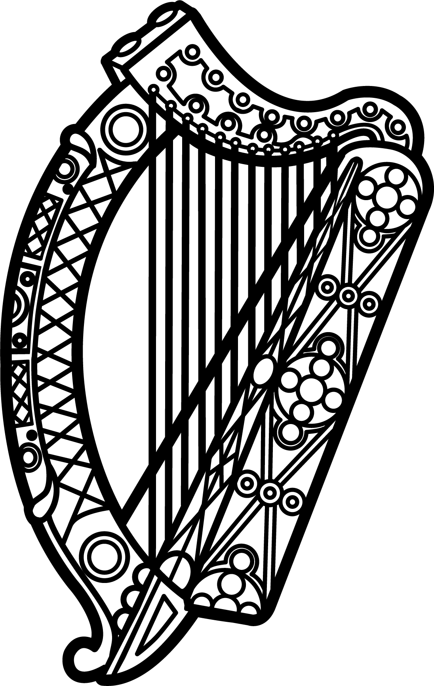

Statement of Ireland
33rd session of the UPR Working Group

Review of Ethiopia

14 May 2019

Ireland warmly welcomes the delegation of Ethiopia.

Ireland commends Ethiopia’s recent efforts to widen the democratic space and enhance the protection and promotion of human rights through a series of comprehensive reforms. We welcome Ethiopia’s strengthened cooperation with UN human rights mechanisms.

We encourage Ethiopia to continue to build effective, accountable and inclusive institutions, and urge the Government to ensure the prompt, impartial and thorough investigation of human rights violations.

Ireland makes the following recommendations:

- Further strengthen cooperation with UN human rights mechanisms, including by extending a standing invitation to all special procedures of the HRC.

- Ensure the protection of the rights of those affected by inter-communal violence, especially the estimated 3.2 million IDPs, by ensuring adherence to humanitarian principles in ongoing plans for return or relocation and by ensuring the safety and security of returning or relocating communities.

We wish Ethiopia every success with this UPR cycle.

Thank you.

