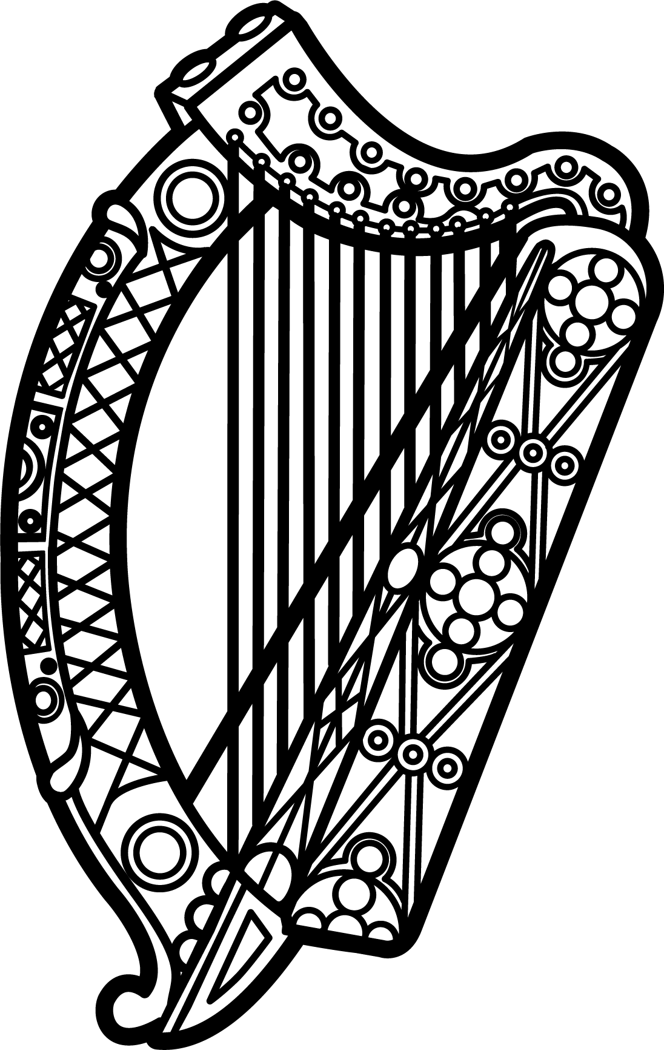

Statement of Ireland
33rd session of the UPR Working Group

Review of Equatorial Guinea

13 May 2019

Thank you, Mr. (Vice) President.

Ireland welcomes the delegation of Equatorial Guinea and thanks it for its presentation today.

Ireland welcomes the recent Presidential announcement of a draft bill to abolish the death penalty. We call on the authorities to take the immediate and necessary steps to ensure its swift implementation.

We remain concerned however, about the lack of progress made by the Government in the promotion and protection of human rights overall, particularly with regard to freedom of expression and association.

Ireland makes the following recommendations to Equatorial Guinea:

- Create and maintain, in law and in practice, a safe and enabling environment for civil society and human rights defenders, including by conducting prompt, thorough and impartial investigations into allegations of intimidation and reprisal against them and by bringing perpetrators to justice.

- Ensure that the independence of the judiciary is fully guaranteed in its legal framework and is in line with the principles of international law.

We wish Equatorial Guinea every success with this UPR cycle.

Thank you.

