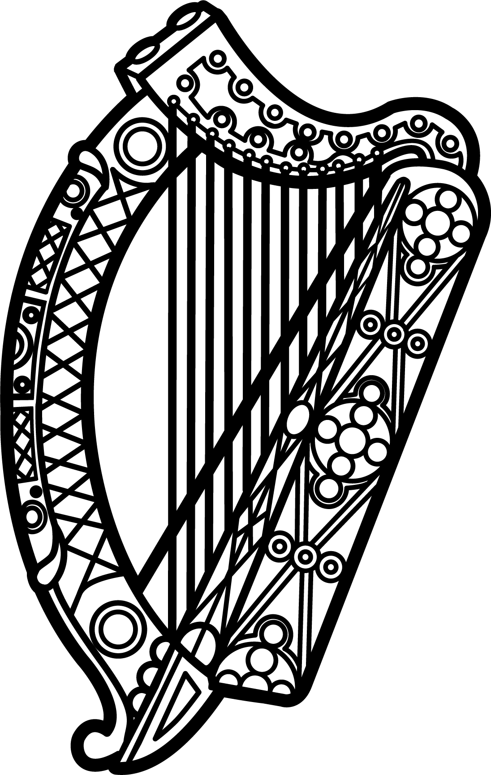

Statement of Ireland
33rd session of the UPR Working Group

Review of Dominica

9 May 2019

Thank you, Mr. (Vice) President.

Ireland warmly welcomes the delegation of Dominica and thanks it for its presentation today.

Ireland recognises that Dominica is particularly vulnerable to climate-related disasters and the serious challenges that ensue. We welcome the Government’s commitment to become a “climate resilient nation”, including through the adoption of the Climate Resilience Act in 2018 and the establishment of a climate resilience executive agency for Dominica.

We commend measures taken to combat gender-based violence, such as the amendment of the Sexual Offences Act, 2016, and urge the Government to continue progress in this area.

Ireland makes the following recommendations to Dominica:

- Decriminalise defamation and place it under the Civil Code, in accordance with international standards, particularly regarding freedom of opinion and expression.

- Adopt concrete measures to combat discrimination based on sexual orientation and gender identity, including by repealing Article 16 of the Sexual Offences Act 1998, to decriminalise consensual same-sex relations.

We wish Dominica every success with this UPR cycle.

Thank you.

