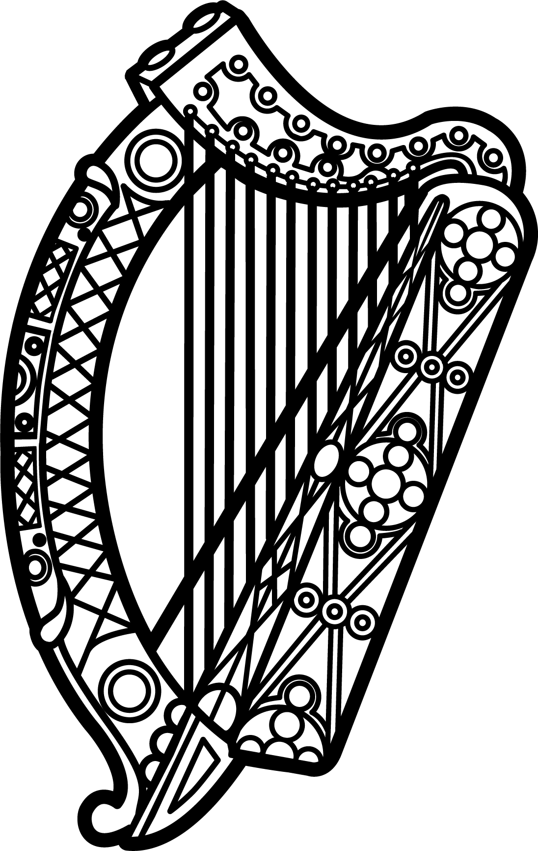

Statement of Ireland
33rd session of the UPR Working Group

Review of the Democratic Republic of the Congo

7 May 2019

Thank you, Mr (Vice) President.

Ireland welcomes the delegation of the Democratic Republic of the Congo.

Ireland remains deeply concerned about reports of human rights violations committed before, during and after the elections of December 2018, as highlighted by the High Commissioner in her most recent report to the Human Rights Council.

We are particularly troubled by the undue restrictions on civil society and the violent repression of peaceful demonstrations. We urge the Government to ensure fundamental freedoms are upheld and to carry out independent, credible and impartial investigations into all allegations of excessive use of force by members of the defences forces and security services.

Ireland makes the following recommendations to the Congolese authorities:

- Ensure journalists, opposition leaders, human rights defenders and other civil society actors are able to freely exercise their rights to freedom of expression, association and peaceful assembly without fear of harassment, intimidation or reprisals.

- Carry out independent, credible and impartial investigations into allegations of sexual and gender based violence in conflict to ensure those responsible may be brought to justice.

We wish the Democratic Republic of the Congo every success with this UPR cycle.

Thank you.

