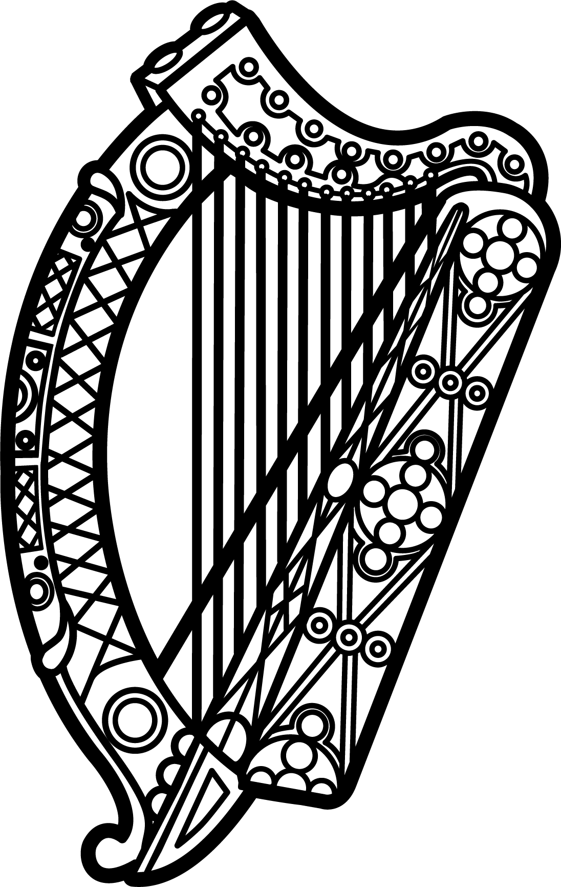

Statement of Ireland
33rd session of the UPR Working Group

Review of the Democratic People's Republic of Korea

9 May 2019

Thank you, Mr. (Vice) President.

Ireland welcomes the delegation of the Democratic People’s Republic of Korea (DPRK).

Ireland remains deeply concerned by the grave situation of human rights in the country. We are particularly troubled by findings of the Special Rapporteur on the situation of human rights in the DPRK in his most recent report to the Human Rights Council in March.

Ireland recognises that over the past year, there have been some positive developments on the Korean Peninsula. We welcome the increased and improved engagement and high-level talks between the Republic of Korea and the DPRK, and between the DPRK and the US. However, we remain concerned that little progress has been made in addressing the systemic human rights violations in the country.

Ireland makes the following recommendations:

- Grant immediate, free and unimpeded access to international humanitarian organisations to provide assistance to the most vulnerable groups, including prisoners.

- Allow Christians as well as persons belonging to any other religious community or group to exercise their religion independently and publicly, without fear of punishment, reprisal or surveillance.

We wish the Democratic People’s Republic of Korea every success with this UPR cycle.

Thank you.

