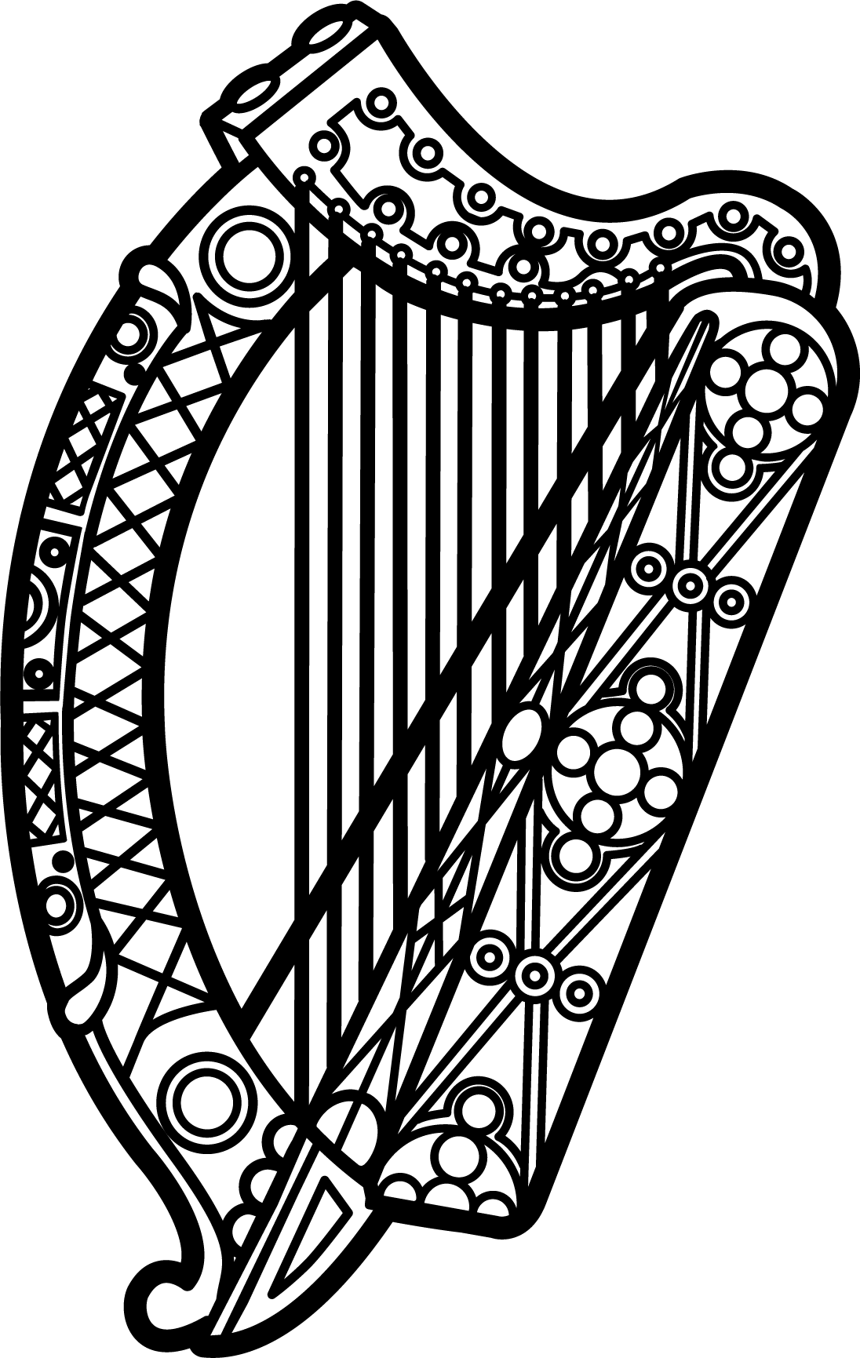

Statement of Ireland
33rd session of the UPR Working Group

Review of Côte d'Ivoire

7 May 2019

Thank you, Mr (Vice) President.

Ireland warmly welcomes the delegation of Côte d'Ivoire and thanks it for its presentation.

Ireland acknowledges efforts by Côte d'Ivoire to advance human rights domestically and commends progress made since the last UPR cycle.

We welcome the recent effort to reform the national human rights institution and urge the Government to ensure it now enjoys the resources and operational independence necessary to discharge its mandate in full compliance with the Paris Principles.

Ireland makes the following recommendations:

- Amend all legislation that discriminates on the basis of sexual orientation or gender identity, including Article 360 of the Criminal Code, and take concrete steps to protect LGBTI individuals from acts of violence, discrimination and harassment.

- Ensure journalists, human rights defenders and other civil society actors are able to freely exercise their rights to freedom of expression, association and peaceful assembly without fear of reprisals, intimidation or harassment, in particular in the context of the upcoming presidential election in 2020.

We wish Côte d'Ivoire every success with this UPR cycle.

Thank you.

