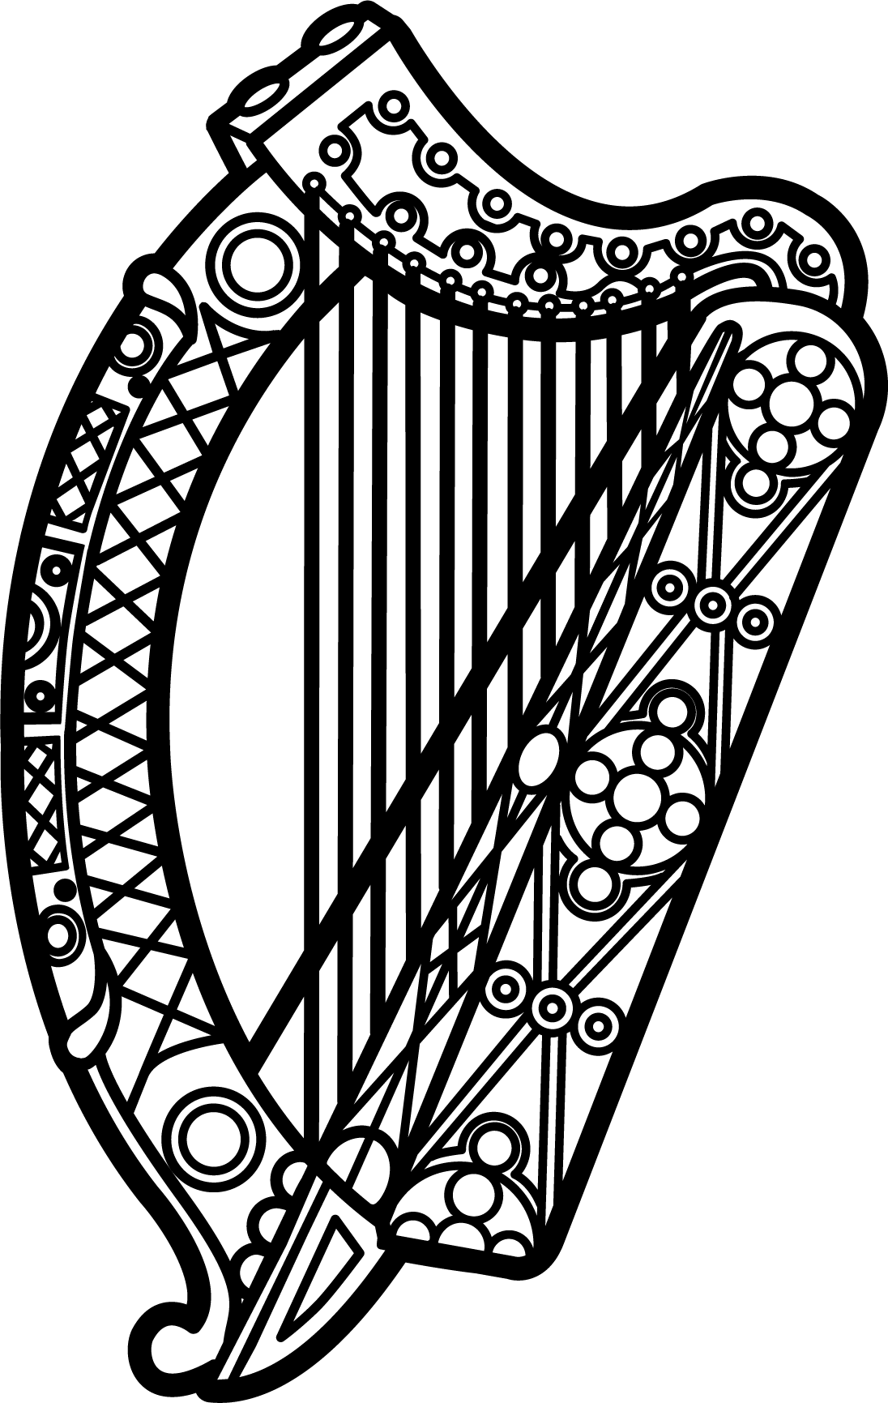

Statement of Ireland
33rd session of the UPR Working Group

Review of Brunei Darussalam

10 May 2019

Thank you, Mr. (Vice) President.

Ireland welcomes the delegation of Brunei Darussalam and thanks it for its presentation.

Ireland once again expresses our grave concern about the recent implementation of the 2013 Penal Code Order, under which certain provisions amount to torture, acts of cruel, inhuman or degrading treatment. We welcome the recent statement announcing a moratorium on the use of the death penalty under these provisions and hope it will be followed by the formal abolition of its use.

We call on the Government to take urgent steps to ensure it upholds its international human rights obligations and commitments.

Ireland makes the following recommendations to Brunei Darussalam:

- Repeal the new provisions of the revised Penal Code which, if implemented, will enshrine in legislation a range of extreme punishments that amount to torture, acts of cruel, and inhuman or degrading treatment.

- Ratify the UN Convention Against Torture at the earliest opportunity.

We wish Brunei Darussalam every success with this UPR cycle.

Thank you.

