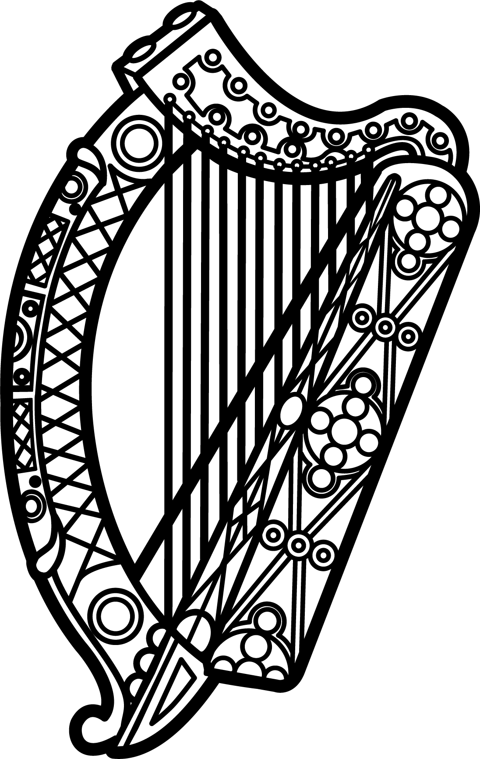

Statement of Ireland
33rd session of the UPR Working Group

Review of Bhutan

8 May 2019

Thank you, Mr. (Vice) President.

Ireland warmly welcomes the delegation of Bhutan and thanks it for its presentation today.

Ireland acknowledges Bhutan’s efforts to advance human rights domestically since the previous UPR cycle, including the adoption of its most recent Five Year Plan (2018-2023), which, among other objectives, incorporates implementation of the 2030 Agenda for Sustainable Development.

Despite this progress Ireland remains concerned about the particular vulnerability of LGBTI persons to discrimination and harassment in Bhutan.

Ireland makes the following recommendations:

- Decriminalise consensual same-sex conduct by repealing or amending Sections 213 and 214 of the Penal Code of Bhutan.

- Ratify all core international human rights instruments, most notably the International Covenant on Economic, Social and Cultural Rights and the International Covenant on Civil and Political Rights.

We wish Bhutan every success with this UPR cycle.

Thank you.

