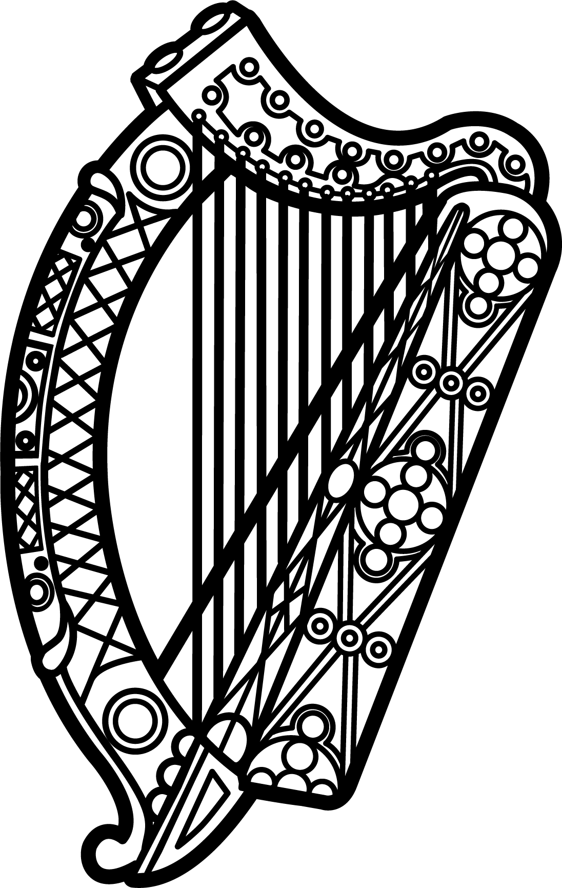

Statement of Ireland
33rd session of the UPR Working Group

Review of Albania

6 May 2019

Thank you, Mr (Vice) President.

Ireland warmly welcomes the delegation of Albania and thanks them for their presentation.

Ireland acknowledges Albania’s efforts to advance human rights domestically and commends progress made since the last UPR cycle.

We welcome the development and implementation of comprehensive reform strategies across the public sector, including the justice system, and encourage the Government to continue building effective, accountable and inclusive institutions at all levels in line with SDG16.

Ireland makes the following recommendations to the Albanian authorities:

- Ensure all mechanisms and state institutions mandated by Law no. 18/2017 to promote, protect and fulfil the rights of children, including the Office of the People’s Advocate, are appropriately funded and adequately resourced.

- Intensify efforts to protect lesbian, gay, bisexual, transgender and intersex individuals from acts of violence, discrimination and harassment by fully implementing the National Action Plan for LGBTI Persons 2016-2020 and amending the Family Code to provide legal recognition of same-sex partnerships.

We wish Albania every success with this UPR cycle.

Thank you.

